AI Powered Intelligent Hospital Patient Flow Management System
SCOPE AND LIMITATIONS

Student | Hall Ticket No.
A. RAMU | 23K91A6715
B. RUSHI | 23K91A6720
B. RAJ KUMAR | 23K91A6725
A. PRABHAS | 23K91A6703
Under the guidance of [GUIDE NAME]
Department of Computer Science and Engineering (Data Science)
[COLLEGE NAME]
[ACADEMIC YEAR]

1. Scope
CareFlow covers the operational journey of a patient from registration through department queues, consultation, laboratory work, admission and discharge. It provides staff-facing role dashboards and a public waiting-room board. The prototype is intended for academic demonstration of coordinated flow, not autonomous diagnosis or production clinical use.
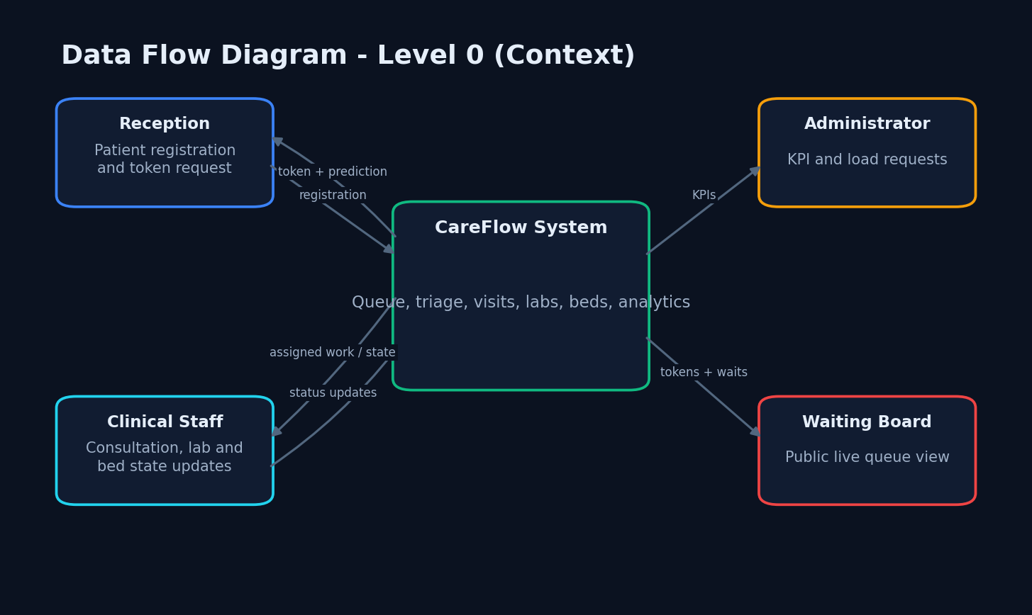
Figure 1. System boundary and external actors.

2. Functional Scope
Table 1. In-scope functions.
Area | Included capability
Reception | Create patient/visit, token, triage and wait estimate
Doctor | View queue, assign consultation, order lab, admit, discharge
Laboratory | View and progress test work
Nursing | View ward/ICU beds, update or release resources
Administration | KPIs, department load, bed and ICU occupancy
Public display | Now-serving token, upcoming tokens and expected wait

3. Non-Functional Scope
The implementation demonstrates authenticated role separation, structured validation, responsive browser interfaces, local persistence, live update delivery and reproducible model loading. Performance evidence is limited to sequential loopback requests on one Windows workstation.
Maintainability is supported by route, schema, service, model and ML modules. Portability is demonstrated only for the documented local Python and Node.js setup; container or cloud deployment was not implemented.

4. Assumptions
The two-server default used by wait inference is an operational simplification. Department average service minutes are configuration data. Staff use correct roles and keep states current. Synthetic demonstration visits are assumed to be sufficient for UI verification. Missing vitals are completed with neutral defaults, which can hide uncertainty and is unsuitable for clinical use without explicit warnings.

5. Out of Scope
Table 2. Deliberate exclusions.
Excluded item | Reason / boundary
Diagnosis and treatment recommendation | No validated clinical model
Real EHR/HIS integration | No external hospital interface or standard implemented
Billing, insurance and pharmacy inventory | Outside patient-flow objective
Production identity management | Demo accounts and local JWT only
Mobile application | Implemented as responsive web application
Cloud scaling and disaster recovery | Single local process and SQLite
Real SMS, e-mail or push alerts | No external notification provider

6. Evidence-Based Limitations
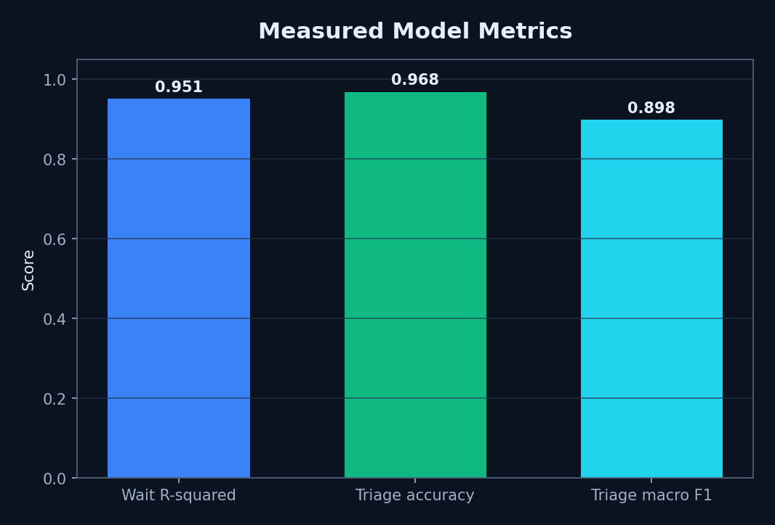
Figure 2. Measured model scores; values are not clinical validation.
Both model datasets are synthetic and generated from designed distributions; they are not real patient records.
The measured model test partitions come from the same deterministic generators as training and are not independent clinical validation.
No real hospital deployment, clinician study, user-acceptance study, security audit, accessibility audit, or concurrent-load test was performed.
The 96.80% triage accuracy must be interpreted with the 63% critical-class recall; accuracy alone overstates safety-critical performance.
SQLite, a development JWT secret fallback, an unauthenticated WebSocket, and in-process broadcasting are unsuitable for production without hardening.
The landing-page claims of 42% wait reduction, 214 patients, and six departments are hard-coded marketing copy and are excluded from results.

7. Implementation Constraints
The nurse dashboard requires an explicit tab click after first load because the uncontrolled default is calculated before asynchronous department data arrives. The WebSocket is unauthenticated and local to one process. Seeded occupied beds are display records and are not linked to admitted visits. Laboratory progress and visit status are not fully synchronised in every transition.
The checked-in application uses ports 8010 and 5173, although the documentation brief mentions 8110 and 5110. The documents follow the implemented ports.

